The One  D/C C(add9) D/C C(add9) (twice)  D/C C(add9)  I saw you dancing out the ocean  D/C G/B  Running fast along the sand  Gm/Bb Eb  A spirit born of earth and water  F F7  Fire flying from your hands  Bb Eb/Bb  In the instant that you love someone  F/A Bb  In the second that the hammer hits  Fm/Ab G7 F/A  Reality runs up your spine  G7/B Cm Bb/Eb F F7/A  And the pieces finally fit  Bb D7/F#  And all I ever needed was the one  Gm Bb/F  Like freedom feels where wild horses run  Gb Bb/F  When stars collide like you and I  Bb9 Eb Bb/D  No shadows block the sun  Cm7 Cm7/F  You're all I've ever needed  F  Baby you're the one  D/C C(add9)  There are caravans we follow  D/C G/B  Drunken nights in dark hotels  Gm/Bb Eb  When chances breathe between the silence  F F7  Where sex and love no longer gel  Bb Eb/Bb  For each man in his time is Cain  F/A Bb  Until he walks along the beach  Fm/Ab G7 F/A  And sees his future in the water  G7/B Cm Bb/Eb F F7/A  A long lost heart within his reach  SOLO  D/C C(add9) D/C G/B Gm/Bb Eb F  ENDING SOLO  Bb Bb/D Eb Cm F7 | Intro  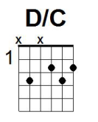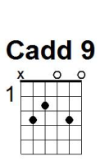  Verse  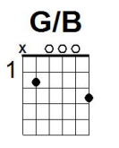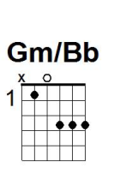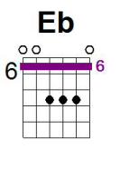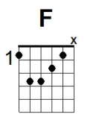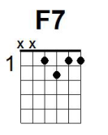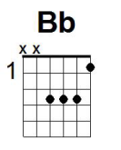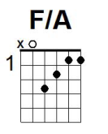  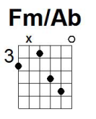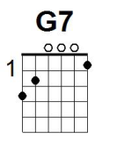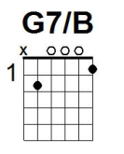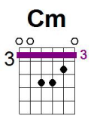  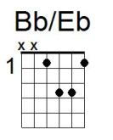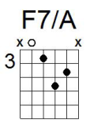  Chorus  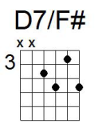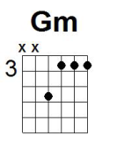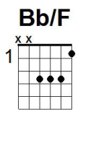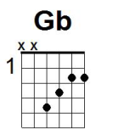  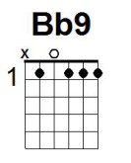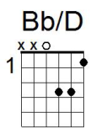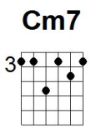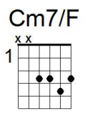  Solo  Ending Solo

